Arbor Day Ceremony

Students who are a part of the Kiwanis Club (K-KIDS) and students in kindergarten participated in an Arbor Day SEL-bration. Students read poems and sang songs with community dignitaries.

Objective: We are learning to read a poem fluently with purpose and understanding.

Standard: RF.K.4. Read emergent text with one-to-one correspondence to develop fluency and comprehension skills.

Assessment: Teachers listened to students’ reading and provided feedback regarding fluency and articulation after the celebration.

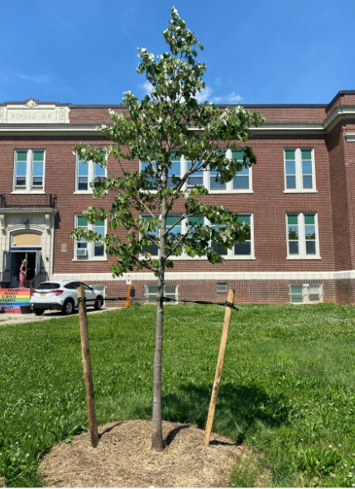

Ordinary

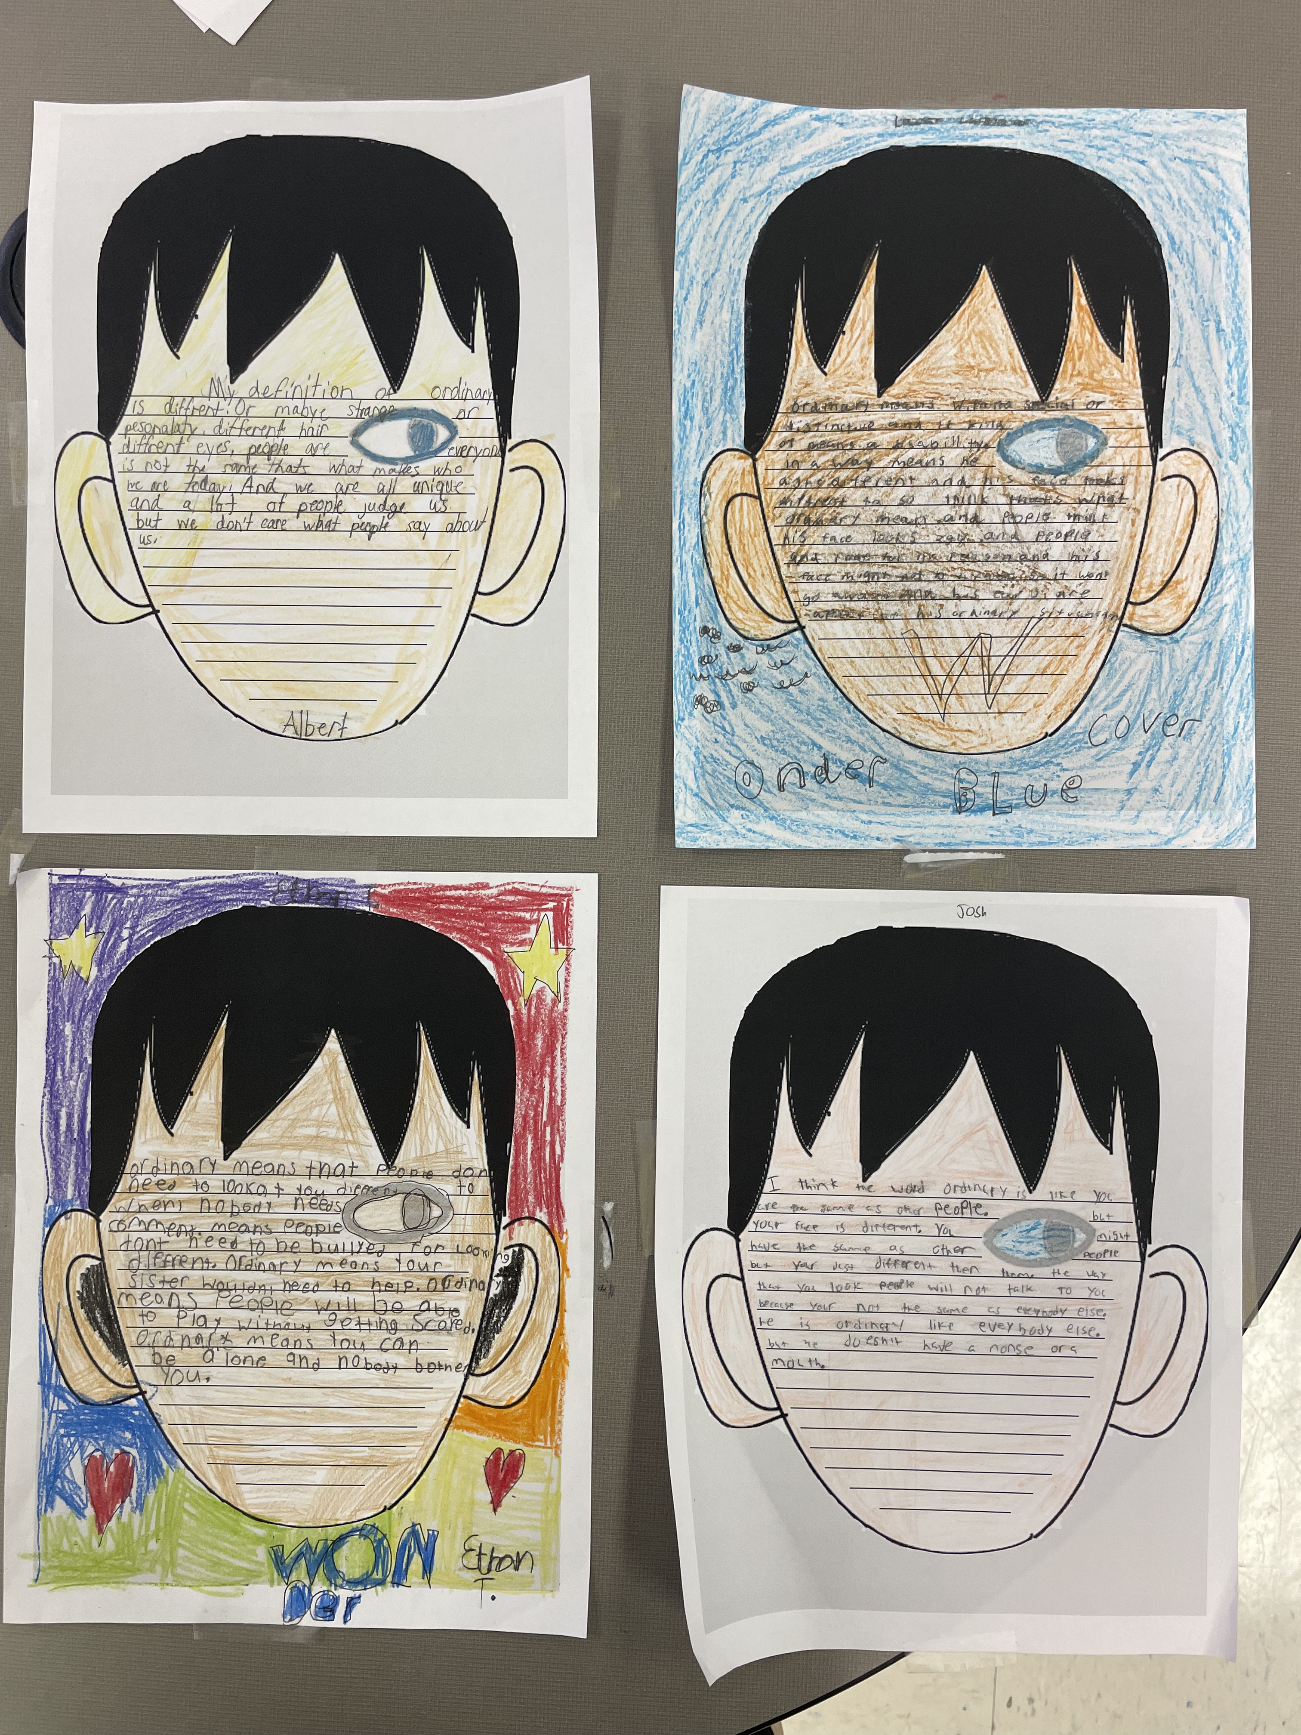

Students read Part One of “Wonder” by R.J. Palacio. Throughout the reading, they learned about the word “ordinary”.

Objective: We are learning to determine the meaning of the word “ordinary” based on context clues from the story.
Standard: RL.4.4. Determine the meaning of words and phrases as they are used in a text, including those that allude to significant characters found in literature.
Assessment: Teachers used a rubric to assess students’ responses. The rubric focused on the student’s ability to use context clues and define a word within a text.

Reading Challenge

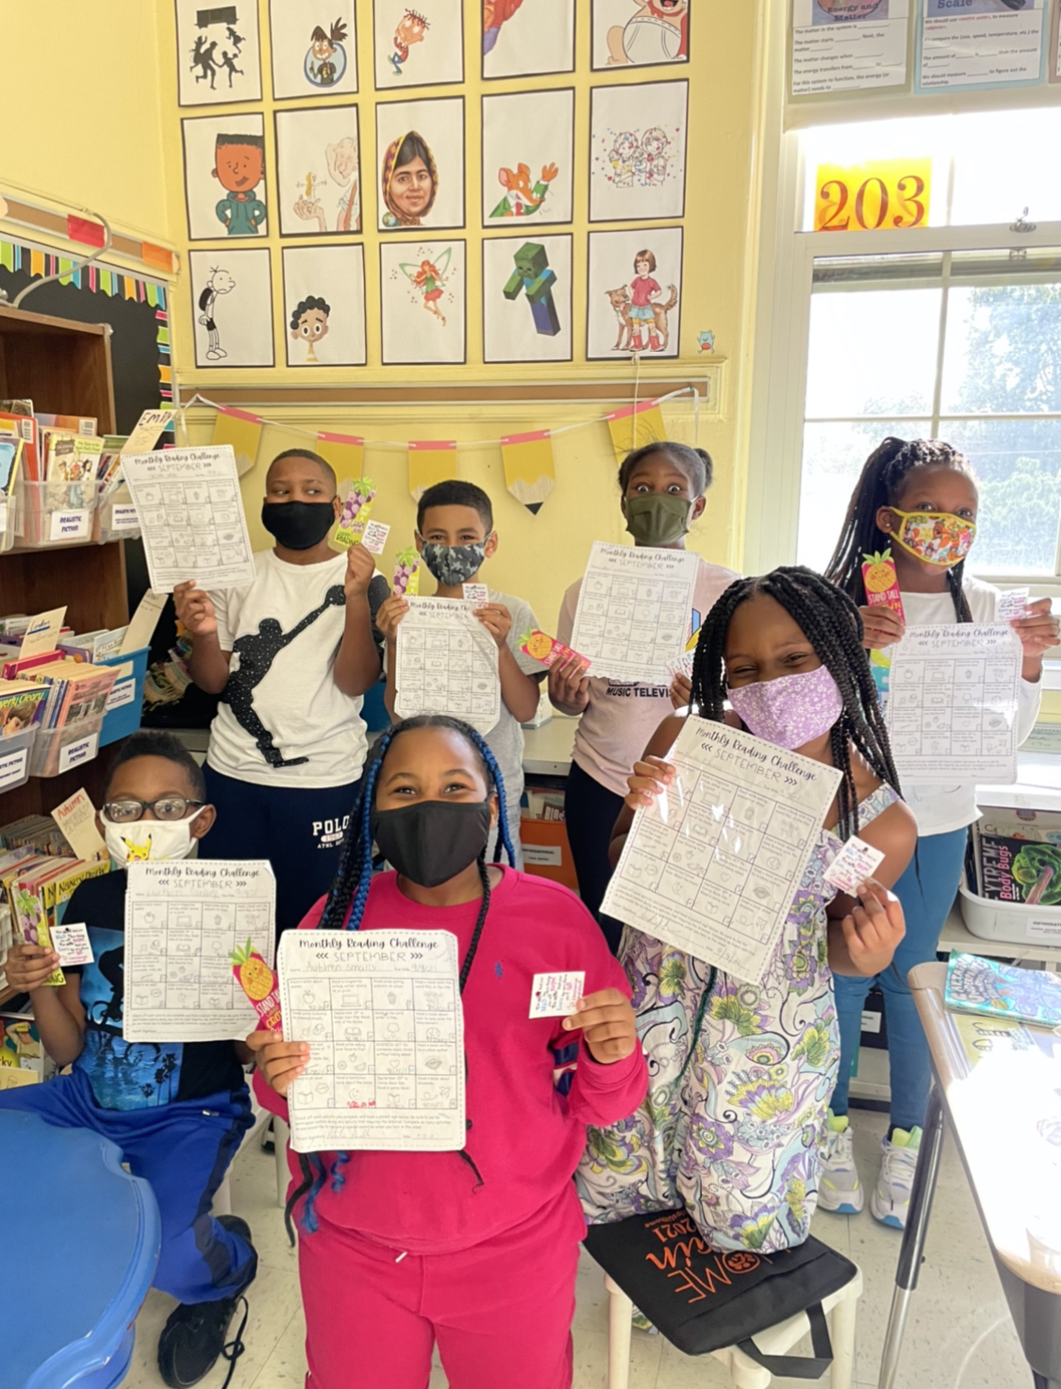

Students participated in a monthly reading challenge. These challenges provided students the opportunity to read with family members, as well as explore new genres and authors. At the end of the monthly challenge on SEL days, students were celebrated for their accomplishments.

Objective: We are learning to read a variety of texts at different text complexities.

Standard:
- RL.4.10. By the end of the year, read and comprehend literature, including stories, dramas, and poems at grade level text-complexity or above, with scaffolding as needed.
- RI.4.10. By the end of year, read and comprehend literary nonfiction at grade level text-complexity or above, with scaffolding as needed
Assessment: Students completed a challenge log with their parent/guardian. The teacher and student reflected on the challenge and discussed goal setting for the following month.

Gratitude

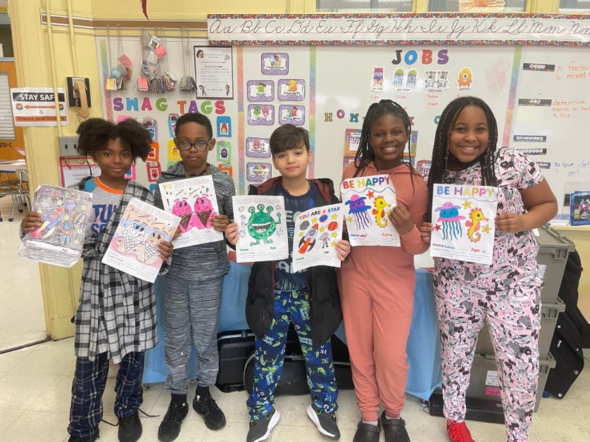

Students took part in creating colorful artwork along with letters of gratitude to Veterans, as well as active military members.

Objective: We are learning to write a friendly letter to thank our Veterans and other members of the military. We will explain reasons why we are grateful for their service.
Standard: W.4 Produce clear and coherent writing in which the development and organization are appropriate to task, purpose, and audience.
Assessment: Teachers used a writing rubric focusing on organization, spelling, grammar, and clarity of writing.

Kind Hearts

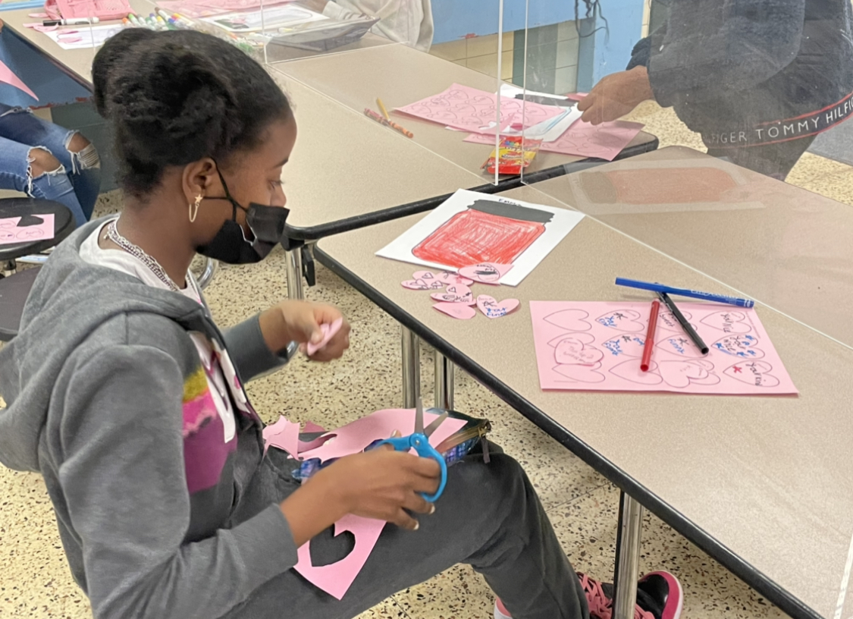

Students participated in a class discussion in which they highlighted positive characters traits that their peers have demonstrated. Each student wrote one character trait about each student in their class. Students then created their own jar to collect character traits that their peers wrote about them. Finally, students chose one character trait to write about in more detail about another classmate.

Objective: We are learning to support our opinions through writing about a character trait that is demonstrated by another classmate.
Standard: W.5.1. Write opinion pieces on topics or texts, supporting a point of view with reasons and information.
Assessment: Teachers used a writing rubric focusing on the student’s ability to state a clear opinion and provide logical reasoning.

SEL – Day Schedule

