Welcome to APUSH

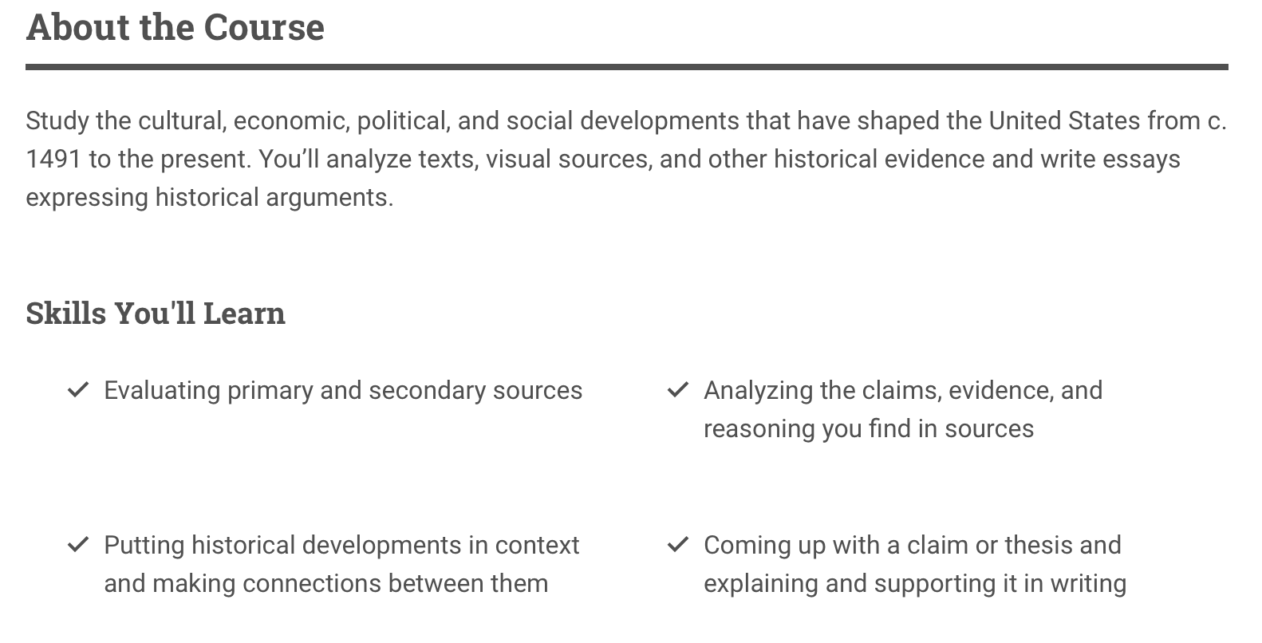

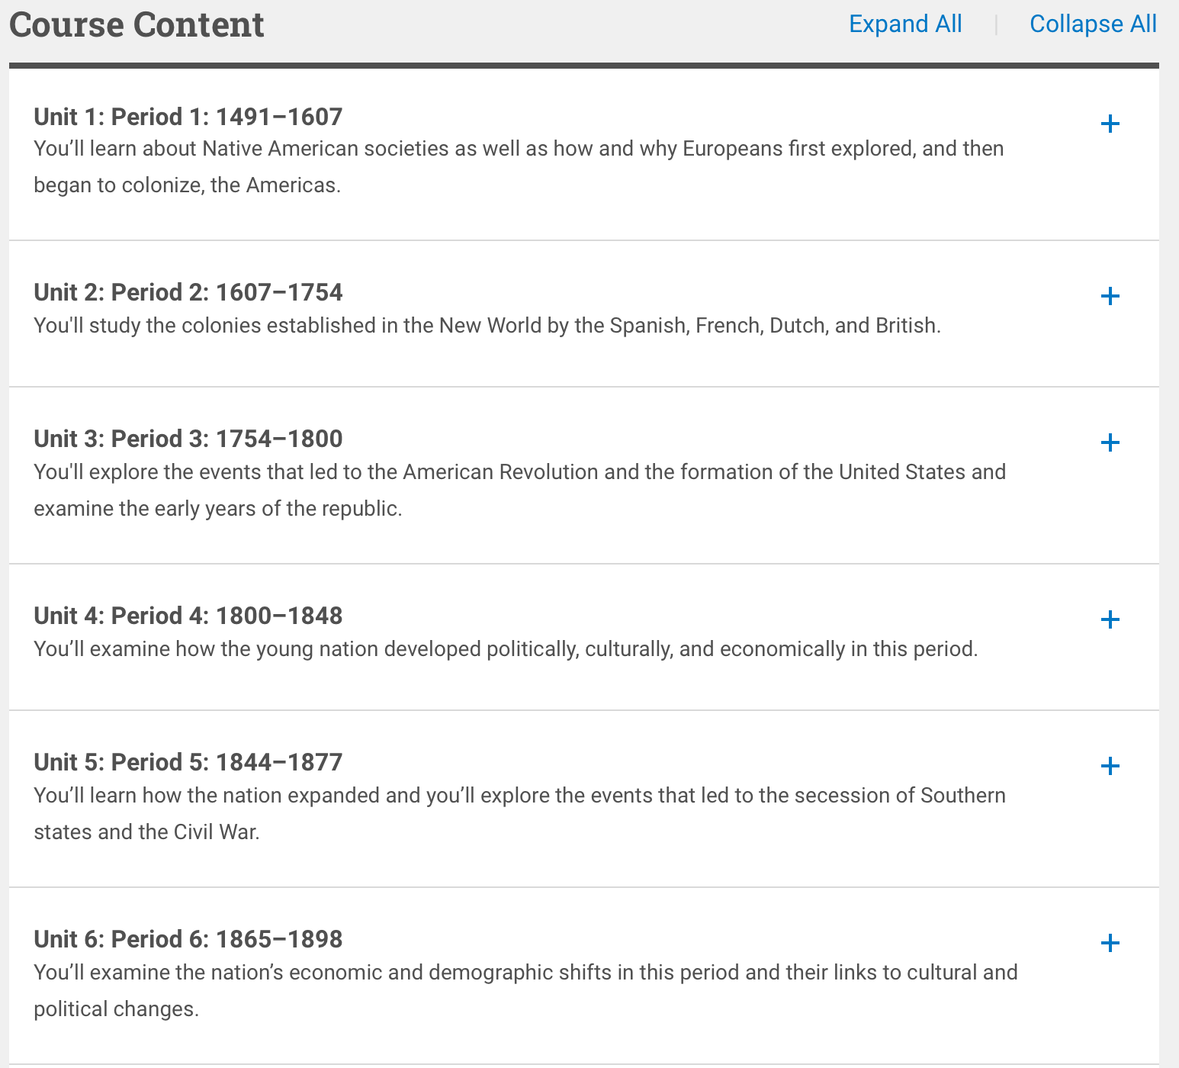
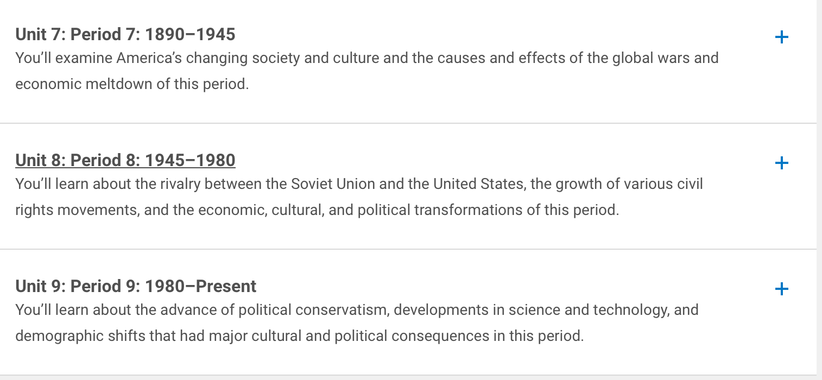

Please understand this is a rigorous course that moves fast and will take a lot of effort for you to pass. This is a commitment to working hard and trying your best to pass not only the class, but the APUSH exam.

ASSIGNMENT #1: Historical Fiction

DUE DATE: Sept 1, 2023 11:59pm.
E-mail the completed paper to JOrth@lindenps.org

1) Choose ONE of the following books for analysis (If you click on the book cover you will be directed to the Amazon website if you would like to order through there). Each discusses a topic covered AP History.

2) In order to get the work for the book you must email me at --JOrth@lindenps.org – subject line (summer book work)

If this is not complete you will begin the year with a 0 on a major project grade.

This completed document must be emailed to me by Sept 1 @ Jorthlindenps.org

Be prepared to discuss your book as well the first week of school.

U.S. Imperialism
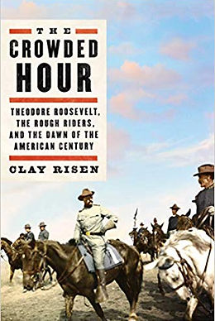
The dramatic story of the most famous regiment in American history: the Rough Riders, a motley group of soldiers led by Theodore Roosevelt, whose daring exploits marked the beginning of American imperialism in the 20th century.
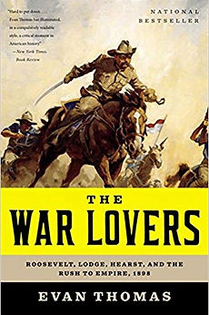
On February 15th, 1898, the American battleship USS Maine mysteriously exploded in the Havana Harbor. News of the blast quickly reached U.S. shores, where it was met by some not with alarm but great enthusiasm.
A powerful group of war lovers agitated that the United States exert its muscle across the seas.

World War I
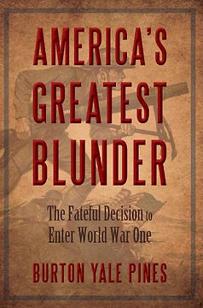
The tale of how America entered into the war. Chronicles how America abandoned sensible neutrality, how British anti-German propaganda in America succeeded and German propaganda failed, how America mobilized an army of millions while igniting “white hot” fervor of patriotism at home and how the war could have ended differently had America not entered.
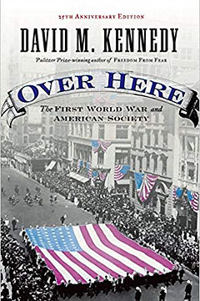
The Great War of 1914-1918 confronted the United States with one of the most wrenching crises in the nation's history. It also left a residue of disruption and disillusion that spawned an even more ruinous conflict scarcely a generation later.Over Here is the single-most comprehensive discussion of the impact of World War I on American society. An American history classic, Over Here reflects on a society's struggle with the pains of war, and offers trenchant insights into the birth of modern America.
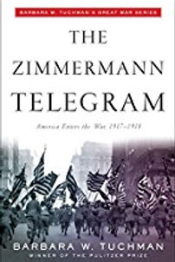
In January 1917, the war in Europe was, at best, a tragic standoff. Britain knew that all was lost unless the United States joined the war, but President Wilson was unshakable in his neutrality. At just this moment, a crack team of British decoders in a quiet office known as Room 40 intercepted a document that would change history.

The Great Depression
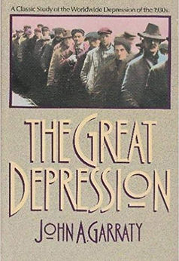
Inquiring into the worldwide depression of the 1930s and examining its sources and implications, this study focuses on the collapse of the world. Garraty succeeds marvelously in doing what few recent writers on the Depression have even attempted: treating the economic crisis of the Thirties as a worldwide event. With this approach, he brings genuinely new insight to the topic. By examining how major Western nations suffered through and reacted to the Depression, he broadens our knowledge of the world in that era.
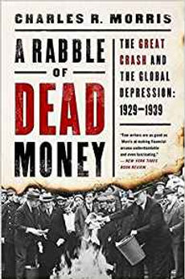
The Great Crash of 1929 profoundly disrupted the United States' confident march toward becoming the world's superpower. The breakneck growth of 1920s America--with its boom in automobiles, electricity, credit lines, radio, and movies--certainly presaged a serious recession by the decade's end, but not a depression. The totality of the collapse shocked the nation, and its duration scarred generations to come. Charles R. Morris pulls together the intricate threads of policy, ideology, international hatreds, and sheer individual
cantankerousness that finally pushed the world economy over the brink and into a depression.
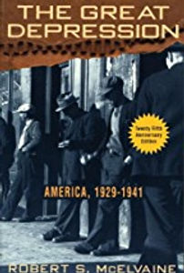
One of the classic studies of the Great Depression, featuring a new introduction by the author with insights into the economic crises of 1929 and today. In the twenty-five years since its publication, critics and scholars have praised historian Robert McElvaine’s sweeping and authoritative history of the Great Depression as one of the best and most readable studies of the era.
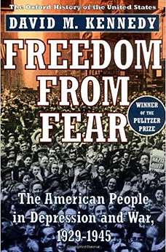
Between 1929 and 1945, two great travails were visited upon the American people: the Great Depression and World War II. This book tells the story of how Americans endured, and eventually prevailed, in the face of those unprecedented calamities. Freedom From Fear explores how the nation agonized over its role in World War II, how it fought the war, why the United States won, and why the consequences of victory were sometimes sweet, sometimes ironic.

World War II
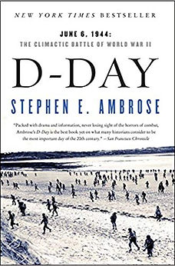
D-Day is the epic story of men at the most demanding moment of their lives, when the horrors, complexities, and triumphs of life are laid bare. Distinguished historian Stephen E. Ambrose portrays the faces of courage and heroism, fear and determination—what Eisenhower called “the fury of an aroused democracy”—that shaped the victory of the citizen soldiers whom Hitler had disparaged.
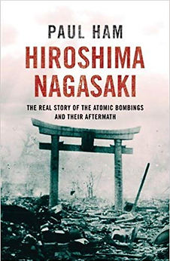
This harrowing history of the Hiroshima and Nagasaki bombings draws on extensive research and hundreds of interviews. In this gripping narrative, Ham demonstrates convincingly that misunderstandings and nationalist fury on both sides led to the use of the bombs and gives powerful witness to its destruction.
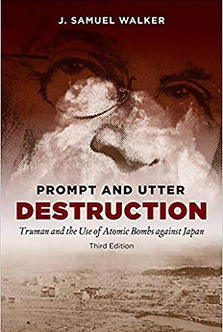
In this concise account of why America used atomic bombs against Japan in 1945, J. Samuel Walker analyzes the reasons behind President Truman's most controversial decision. Delineating what was known and not known by American leaders at the time, Walker evaluates the options available for ending the war with Japan. In this new edition, Walker incorporates a decade of new research--mostly from Japanese archives only recently made available--that provides fresh insight on the strategic considerations that led to dropping the bomb.

The Cold War
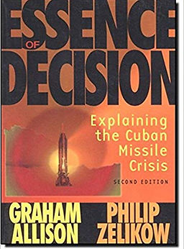
One of the most influental political science works written in the post World War II era, the original edition of Essence of Decision is a unique and fascinating examination of the pivotal event of the Cold War. This classic text is a fresh reinterpretation of the theories and events surrounding the Cuban Missle Crisis. A vivid look at decision-making under pressure that attempts to answer the enduring question: how should citizens understand the actions of their government?
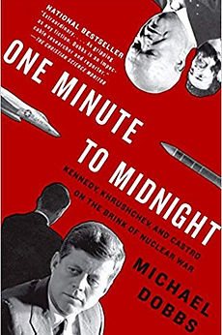
In October 1962, at the height of the Cold War, the United States and the Soviet Union came to the brink of nuclear conflict over the placement of Soviet missiles in Cuba. In this hour-by-hour chronicle of those tense days, veteran Washington Post reporter Michael Dobbs reveals just how close we came to Armageddon. Written like a thriller, One Minute to Midnight is an exhaustively researched account of what Arthur Schlesinger, Jr. called “the most dangerous moment in human history,” and the definitive book on the Cuban missile crisis.

ASSIGNMENT #2: - Native American Cultures

DUE DATE: First Day of School

- You are to log into the website : https://www.tomrichey.net/apush-summer-assignments.html

Part 1 - Native American Cultures

Watch the YouTube video that correlates with Assignment 1 and complete the graphic organizer below.

Print out : https://www.tomrichey.net/uploads/3/2/1/0/32100773/apush_graphic_organizer_native_american_cultures.pdf If you need more space than what is provided print out two or three……

Part 2 Columbian Exchange & Atlantic Trade
Print out and complete using the videos on the website above. Once again if you need more space please print multiple. https://www.tomrichey.net/uploads/3/2/1/0/32100773/apush_graphic_organizer_columbian_exchange.pdf

Part 3 - Colonial Encounters Video Lectures
Print out the following graphic organizer: https://www.tomrichey.net/uploads/3/2/1/0/32100773/apush_graphic_organizer_european_colonizers.pdf

Watch the 5 videos that go along with this graphic organizer and complete. If you need more room, print out more than one.

Part 4 - Document Analysis (Colonization)
Once again print out the following:
https://www.tomrichey.net/uploads/3/2/1/0/32100773/apush_summer_reading_assignment_-_cronon.pdf

Use the reading and excerpts to complete the sheet.

ALL HANDOUTS MUST BE HANDED IN THE FIRST DAY OF SCHOOL.

